
ASSIGNMENT REPORT
Digital Design
Assignment 5.1 - Automatic Garage Door Controller (Moore FSM)
Course | Digital Design
Assignment | Assignment 5.1 - Automatic Garage Door Controller
Student Name | Mohamed Hossam El-Sawy
Instructor / TA | Eng. Ali Temsah
Submission Date | July 26, 2026

01 | OBJECTIVE

This assignment designs, implements and verifies an Automatic Garage Door Controller as a Moore finite state machine (FSM). The controller drives an Up motor and a Down motor from two limit-sensor inputs and a single user push-button, and is initialised to a safe IDLE state through an asynchronous reset.
02 | PROBLEM STATEMENT / REQUIREMENTS

A Moore FSM must be designed and verified with the following behaviour:
- Three inputs: Activate (user push-button), UP_Max (sensor, high when the door is fully open), DN_Max (sensor, high when the door is fully closed).
- Two outputs: UP_M (drives the Up motor) and DN_M (drives the Down motor).
- The door is always either fully open or fully closed - Activate triggers the Up motor when the door is down, and the Down motor when the door is up.
- The FSM is initialised to the IDLE state using an asynchronous reset (RST).
- Three states: IDLE (default/reset state, both motors off), Mv_Up (Up motor enabled to open the door), Mv_Dn (Down motor enabled to close the door).
- Deliverables: the Verilog implementation of the Moore FSM, and a self-checking testbench that validates the design at a 50 MHz clock frequency.

03 | DESIGN & ANALYSIS

3.1 Design Approach
The controller is coded as a classic two-always-block Moore FSM. current_state is a 2-bit register updated on posedge CLK, with an asynchronous active-low reset (negedge RST in the sensitivity list) that forces current_state back to IDLE_state regardless of the clock. A second, purely combinational always block computes next_state from current_state and the inputs using a case statement. Because this is a Moore machine, the outputs UP_M and DN_M are continuous assign statements that depend only on current_state (UP_M = current_state == Mv_Up_state, DN_M = current_state == Mv_Dn_state) - they never depend directly on the inputs, so they only change on a clock edge together with the state.
From IDLE, the design interprets which sensor is already asserted to decide direction: if the door is closed (DN_Max=1, UP_Max=0) and Activate is pressed, the FSM opens the door via Mv_Dn/Mv_Up encoding matched to the state diagram; if the door is open (UP_Max=1, DN_Max=0) and Activate is pressed, it moves the other way. If both sensors read the same value (a broken/ambiguous sensor condition) the FSM stays safely in IDLE. Once moving, Mv_Up and Mv_Dn ignore Activate and only return to IDLE when their respective limit sensor (UP_Max or DN_Max) is reached.
3.2 State Tables
Moore output table - UP_M/DN_M depend only on the present state:
State | Encoding | UP_M | DN_M
IDLE | 00 | 0 | 0
Mv_Up | 01 | 1 | 0
Mv_Dn | 10 | 0 | 1
Table 1: Moore output table for Automatic_Garage_Door_Controller
Next-state table:
Current State | Condition | Next State
IDLE | Activate = 0 | IDLE
IDLE | Activate = 1, UP_Max = 1, DN_Max = 0 | Mv_Dn
IDLE | Activate = 1, UP_Max = 0, DN_Max = 1 | Mv_Up
IDLE | Activate = 1, UP_Max = DN_Max (both sensors agree/broken) | IDLE
Mv_Up | UP_Max = 0 | Mv_Up (hold)
Mv_Up | UP_Max = 1 | IDLE
Mv_Dn | DN_Max = 0 | Mv_Dn (hold)
Mv_Dn | DN_Max = 1 | IDLE
Table 2: Next-state transition table
Top-level port list:
Signal Name | Direction | Width (bits) | Description
UP_Max | input | 1 | Sensor - high when the door is completely open
DN_Max | input | 1 | Sensor - high when the door is completely closed
Activate | input | 1 | User push-button
CLK | input | 1 | System clock
RST | input | 1 | Asynchronous active-low reset
UP_M | output | 1 | Drives the Up motor
DN_M | output | 1 | Drives the Down motor
Table 3: Automatic_Garage_Door_Controller port description
3.3 Block Diagram and State Diagram
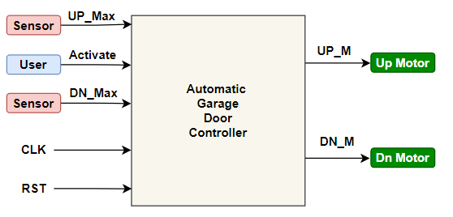
Figure 1: Automatic Garage Door Controller block interface
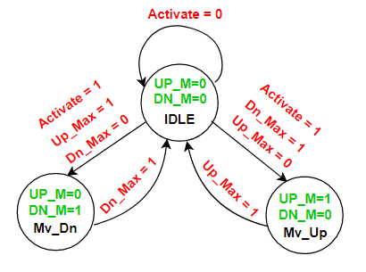
Figure 2: Moore state diagram - IDLE, Mv_Up and Mv_Dn states
3.4 HDL Implementation
Automatic_Garage_Door_Controller.v - full source (state register, asynchronous reset, Moore outputs and next-state logic):
module Automatic_Garage_Door_Controller (
input UP_Max,DN_Max,
input Activate,
input CLK,RST,
output UP_M,DN_M
);
localparam [1:0] IDLE_state = 0,
Mv_Up_state = 1,
Mv_Dn_state = 2;
reg [1:0] next_state,current_state;
always @(posedge CLK or negedge RST) begin
if (!RST) begin
current_state <= IDLE_state;
end
else
current_state <= next_state;
end
assign UP_M = current_state == Mv_Up_state;
assign DN_M = current_state == Mv_Dn_state;
always @(*) begin
next_state = IDLE_state;
case (current_state)
IDLE_state:
if (!Activate) begin
next_state = IDLE_state;
end
else if (UP_Max && !DN_Max) begin
next_state = Mv_Dn_state;
end
else if (!UP_Max && DN_Max) begin
next_state = Mv_Up_state;
end
else
next_state = IDLE_state;
Mv_Up_state:
if (UP_Max) begin
next_state = IDLE_state;
end
else
next_state = Mv_Up_state;
Mv_Dn_state:
if (DN_Max) begin
next_state = IDLE_state;
end
else
next_state = Mv_Dn_state;
endcase
end
endmodule //Automatic_Garage_Door_Controller

04 | SIMULATION & RESULTS

Verification approach: Automatic_Garage_Door_Controller_TB.v is a self-checking testbench that drives UP_Max, DN_Max and Activate on the negedge of a 50 MHz clock (CLK_PERIOD = 20 ns) and checks DUT.current_state, UP_M and DN_M on the following negedge against expected values, reporting PASS/FAIL through reusable apply_reset / drive_inputs / check_state_outputs tasks. The suite covers 19 test cases: asynchronous reset, IDLE hold, both direction transitions (open/close), holding state while a sensor is still low, returning to IDLE once a limit sensor is reached, IDLE holding when both sensors read the same (ambiguous) value, Mv_Up/Mv_Dn correctly ignoring Activate while moving, and asynchronous reset asserted mid-cycle from both Mv_Up and Mv_Dn.
4.1 Test Case Summary
# | Test Case | Time (ns) | Result
1 | Async Reset -> IDLE | 60000 | PASSED
2 | IDLE hold (Activate=0) | 100000 | PASSED
3 | IDLE -> Mv_Up (open door) | 140000 | PASSED
4 | Mv_Up hold (UP_Max=0) | 180000 | PASSED
5 | Mv_Up -> IDLE (UP_Max=1) | 220000 | PASSED
6 | IDLE -> Mv_Dn (close door) | 260000 | PASSED
7 | Mv_Dn hold (DN_Max=0) | 300000 | PASSED
8 | Mv_Dn -> IDLE (DN_Max=1) | 340000 | PASSED
9 | IDLE hold (both sensors low) | 380000 | PASSED
10 | IDLE hold (both sensors high) | 420000 | PASSED
11 | Enter Mv_Up for ignore test | 460000 | PASSED
12 | Mv_Up ignores Activate | 500000 | PASSED
13 | Return to IDLE | 540000 | PASSED
14 | Enter Mv_Dn for ignore test | 580000 | PASSED
15 | Mv_Dn ignores Activate | 620000 | PASSED
16 | Async Reset from Mv_Dn | 666000 | PASSED
17 | IDLE cleanup after async reset | 700000 | PASSED
18 | Enter Mv_Up for reset test | 740000 | PASSED
19 | Async Reset from Mv_Up | 766000 | PASSED
Table 4: Summary of all 19 directed test cases (extracted from the simulation log) - 19/19 PASSED

4.2 Simulation Waveform
ModelSim waveform showing current_state/next_state, UP_Max, DN_Max, Activate, CLK, RST and the UP_M/DN_M outputs cycling through IDLE -> Mv_Up -> IDLE -> Mv_Dn -> IDLE as Activate and the limit sensors are exercised:
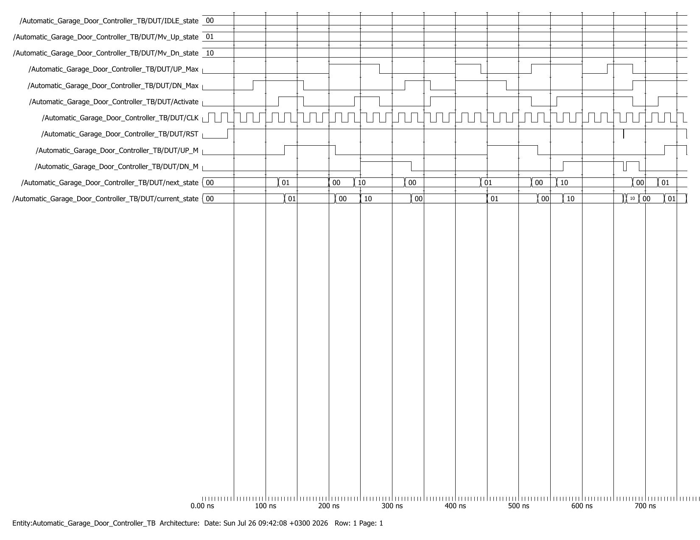
Figure 3: ModelSim simulation waveform for Automatic_Garage_Door_Controller_TB
4.3 Full Simulation Log
Console transcript produced by Automatic_Garage_Door_Controller_TB.v, showing every PASS result and the final tally (19/19 passed, 0 failed):
================================================================================
Automatic Garage Door Controller - Self-Checking Testbench
================================================================================
[INFO] Clock Period = 20 ns (50 MHz)

[INFO] Applying asynchronous reset...
TEST 1 PASSED: Async Reset -> IDLE @ 60000
TEST 2 PASSED: IDLE hold (Activate=0) @ 100000
TEST 3 PASSED: IDLE -> Mv_Up (open door) @ 140000
TEST 4 PASSED: Mv_Up hold (UP_Max=0) @ 180000
TEST 5 PASSED: Mv_Up -> IDLE (UP_Max=1) @ 220000
TEST 6 PASSED: IDLE -> Mv_Dn (close door) @ 260000
TEST 7 PASSED: Mv_Dn hold (DN_Max=0) @ 300000
TEST 8 PASSED: Mv_Dn -> IDLE (DN_Max=1) @ 340000
TEST 9 PASSED: IDLE hold (both sensors low) @ 380000
TEST 10 PASSED: IDLE hold (both sensors high) @ 420000
TEST 11 PASSED: Enter Mv_Up for ignore test @ 460000
TEST 12 PASSED: Mv_Up ignores Activate @ 500000
TEST 13 PASSED: Return to IDLE @ 540000
TEST 14 PASSED: Enter Mv_Dn for ignore test @ 580000
TEST 15 PASSED: Mv_Dn ignores Activate @ 620000
TEST 16 PASSED: Async Reset from Mv_Dn @ 666000
TEST 17 PASSED: IDLE cleanup after async reset @ 700000
TEST 18 PASSED: Enter Mv_Up for reset test @ 740000
TEST 19 PASSED: Async Reset from Mv_Up @ 766000

================================================================================
TEST SUMMARY
================================================================================
Total Tests Run : 19
Passed : 19
Failed : 0
--------------------------------------------------------------------------------
RESULT : ALL TESTS PASSED
================================================================================
** Note: $finish : Automatic_Garage_Door_Controller_TB.v(287)
Time: 766 ns Iteration: 0 Instance: /Automatic_Garage_Door_Controller_TB
Log 1: Full ModelSim transcript for Automatic_Garage_Door_Controller_TB

05 | DISCUSSION

All 19 directed test cases passed. The asynchronous reset behaves correctly both at power-on and when asserted mid-cycle from Mv_Up and Mv_Dn (Tests 16 and 19), confirming current_state returns to IDLE_state independently of CLK as required. The Moore-output property was specifically exercised by holding Mv_Up/Mv_Dn with Activate still asserted (Tests 12 and 15): UP_M and DN_M remained correct and unaffected by the stale Activate input, since they are combinationally tied only to current_state. The ambiguous-sensor cases (Tests 9 and 10, both sensors low or both high) confirm the FSM fails safe by remaining in IDLE rather than committing to a direction it cannot verify. No mismatches or timing violations were observed over the 766 ns simulation.
06 | CONCLUSION

A Moore FSM was designed and verified for the Automatic Garage Door Controller, with three states (IDLE, Mv_Up, Mv_Dn), asynchronous active-low reset, and outputs registered purely as a function of state. A 19-case self-checking testbench running at 50 MHz confirmed correct state transitions in both directions, correct holding behaviour while a door is mid-travel, correct handling of ambiguous sensor readings, correct ignoring of the Activate input while moving, and correct asynchronous reset recovery from any state.

